Week 5 Financial Data Types & Convolutional Neural Networks
SID 2435968

Code

from tensorflow import keras
import tensorflow as tf

model = keras.Sequential([
keras.Input(shape=(50, 5)), # same input as practical session
keras.layers.Conv1D(50, 5, padding='same', activation='relu', kernel_initializer="normal"), # reduced kernel
keras.layers.MaxPooling1D(7),
keras.layers.Conv1D(100, 7, padding='same', activation='relu', kernel_initializer="normal"),
keras.layers.GlobalMaxPooling1D(),
keras.layers.Dense(25, activation='relu', kernel_initializer="normal"),
keras.layers.Dense(2)
])

model.summary()

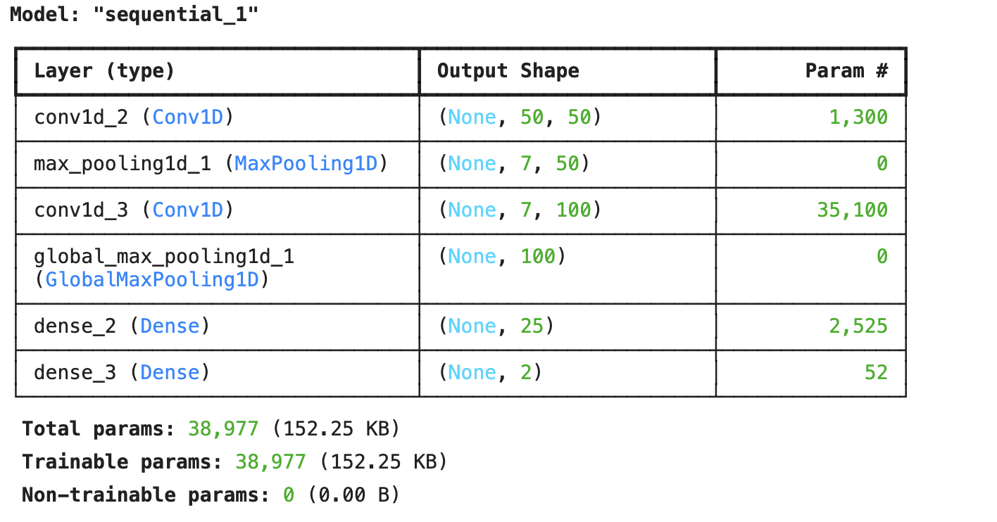

model.compile(optimizer='adam', loss='mse', metrics=['mae'])

import numpy as np

# Convert to NumPy arrays
X_train = np.array(X_train, dtype=np.float32)
y_train = np.array(y_train, dtype=np.float32)
X_test = np.array(X_test, dtype=np.float32)
y_test = np.array(y_test, dtype=np.float32)

# Align lengths just in case
min_len_train = min(len(X_train), len(y_train))
X_train = X_train[:min_len_train]
y_train = y_train[:min_len_train]

min_len_test = min(len(X_test), len(y_test))
X_test = X_test[:min_len_test]
y_test = y_test[:min_len_test]

# Reshape for Conv1D
X_train = X_train.reshape(-1, 50, 5)
y_train = y_train.reshape(-1, 2)
X_test = X_test.reshape(-1, 50, 5)
y_test = y_test.reshape(-1, 2)

history = model.fit(
X_train, y_train,
epochs=14,
batch_size=50,
validation_data=(X_test, y_test),
verbose=1
)

